Proposal for IT1507

**Web Applications Development**

Module Group : BI1706

Name (Admin No.) : Tan Ah Beng (179999Z)

Website Overview

1. *Define the purpose*
2. *Identify the Audience*

This website aims to showcase the different kinds of funerals that cultures all around the world hold for their deceased. It is aimed to be a general knowledge site for the general public. Content is curated from the Internet. All content (textual / images / multimedia) are properly referenced.

Website Design

1. *Plan the Content*

Webpages in the website:

* Homepage
  + Overview
  + Funerals in…
    - Asia
      * Ancient Asia
      * Modern Asia
    - Africa
      * Ancient Africa
      * Modern Africa
    - America
      * Ancient America
      * Modern America
    - Oceania
      * Ancient Oceania
      * Modern Oceania
    - Europe
      * Ancient Europe
      * Modern Europe
    - Tribal
      * Ancient Tribes
      * Modern Tribes
  + About
    - Our Casket Services
    - Customer Feedback
  + Contact Us
    - Our location
    - Feedback Form

1. *Plan the Structure*  (Sitemap done using <https://writemaps.com/> )

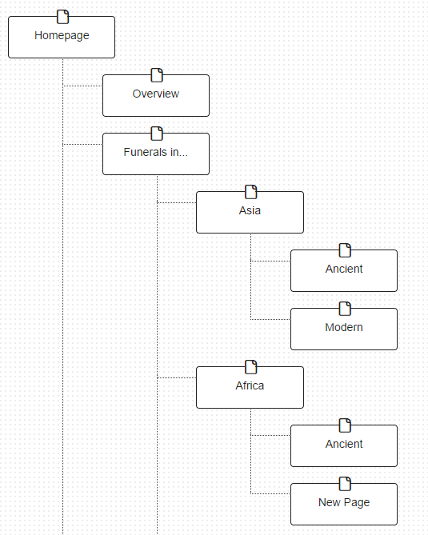

Note to students: I screenshot the map from WriteMaps.com. If your map is too long, it is okay to spill over to more pages.

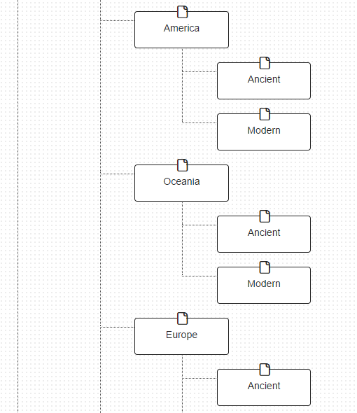

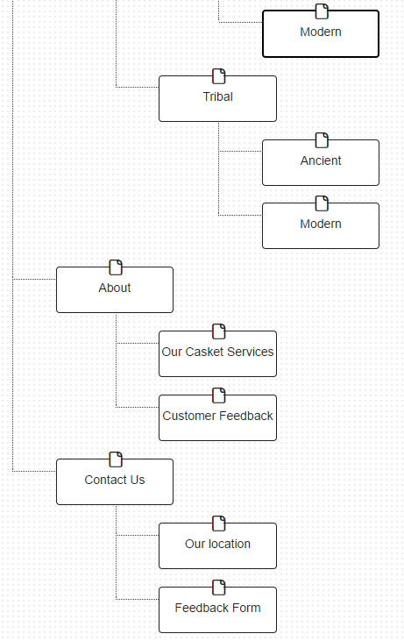

1. *Plan the Web Pages*

* Homepage
  + Animation **(You will be creating this animation)**
  + Videos
* Overview
  + Pictures
  + Videos
* Funerals in…
  + No content. Just in menu.
* Asian - Ancient Asia
  + Table **(At least 1 table)**
  + Pictures
  + Videos
* Asia - Modern Asia
  + Table
  + Pictures
  + Videos
* Africa – Ancient Africa
  + Table
  + Pictures
  + Videos
* Africa – Modern Africa
  + Table
  + Pictures
  + Videos
* America – Ancient America
  + Table
  + Pictures
  + Videos
* America – Modern America
  + Table
  + Pictures
  + Videos
* Oceania – Ancient Oceania
  + Table
  + Pictures
  + Videos
* Oceania – Modern Oceania
  + Table
  + Pictures
  + Videos
* Europe – Ancient Europe
  + Table
  + Pictures
  + Videos
* Europe – Modern Europe
  + Table
  + Pictures
  + Videos
* Tribal – Ancient Tribes
  + Table
  + Pictures
  + Videos
* Tribal – Modern Tribes
  + Table
  + Pictures
  + Videos
* About - Our Casket Services
  + Pictures
* About - Customer Feedback
* Contact Us - Our location
  + Google Map
* Contact Us - Feedback Form
  + Form **(At least 1 form)**

1. *Plan the Navigation*

* **Homepage**

Contact Info

Short Intro

Animation

Navigation

Menu

Banner + Logo

* **And so on and so forth…..**